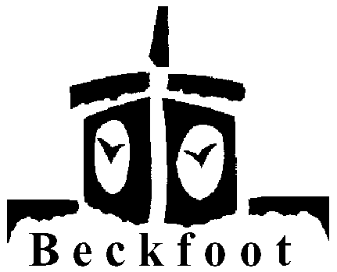 MFL

Year 7 Lesson Plan Half Term 5

Topic – Animals 2

Connect
Recap vocab from last lesson using OHT/labels/ball as Starter – could be used in conjunction with register.

Resources
OHT, labels, Tape Av. 1B/AD1B

Big Picture
Remind pupils that we are learning names of pets to extend personal information

Learning outcomes
To learn 7 new animals and how to describe them using colours

Input
Introduce 7 new animals using colour OHT or FCs + indefinite articles
Cow, donkey, horse, hen, pig, duck, tortoise, snake
Add labels to pictures on board

Activity 1
French – Avantage Tape 1B, side A ex.1B – animal noises
German – Oral/aural exercise to practise new vocabulary

Activity 2
Kinaesthetic activity – labels around room, each pupil has list of animals in English – move around room to fill in names on sheet.
Feedback, individual pupils to fetch correct label to front and stick on board – all pupils to check spelling etc on their own sheet.

Input
Quick revision of colours – touch or point to colour in room.

Demonstrate
Elicit description of animals using question forms based on colour OHT grid.
Eg. le chien est…./der Hund ist …

Review
Each pupil to give different sentence, eg. different animal/colour before they can go.

Preview
To extend descriptions of animals

